Build your strategy!
Now that you’ve chosen your target, it’s time to identify your strategy - a path that gets you from where you are now, to a future where you have won change. This workshop will help you identify the barriers to change, and plan how to remove them, one after another, until you win!

Outcomes of this training
- Understand the key components of a good strategy
- Have a clear vision of the difference between strategy and tactics
- Identify your campaign target’s pillars of support, and your allies and opponents (and how to move them!)
- Start building your own strategy!

Preparation
- Print (or draw) the “pillars of support” and “spectrum of allies” diagram that you’ll find (page 7 & 8) - 10 copies at least & draw each of them on a big piece of paper that you can hang on a wall or on a board.
- You might share the ‘Key Concepts’ (page 3) in advance of the training, to prepare. If not, make sure you confident presenting the concepts to your group - practice!
- If you are unsure, talk to your 350.org contact person or coach.
After your workshop, you can email community@GoFossilFree.org with feedback from your group - what worked well? How can we improve this guide?

Suggested Workshop Outline
~90 minsActivity10 minRitual
By now your group may have some ways it likes to start opening its events. Some ways groups often open include: Singing; Reading, reflection, or prayers; playing a game.
‘Spectrogram’ warmup
“I am going to make some polarizing statements. Please move to that side of the room if you agree, the other if you disagree, or be somewhere in the middle.” After each question, ask 2 or 3 people to share their thoughts. Have fun! Suggested statements:
- “We citizens have more power than our politicians.”
- “Our group does not have much experience.”
- “Our group can make a real change in our town.”
15 minReview briefly key concepts
Strategy > Tactics > Pillars of support > Spectrum of allies25 minWhich are the pillars supporting your local target?
Alone or in pairs (or in small groups), draw the diagram of your campaign’s target pillars of support. Are there one or two that make sense to focus on?25 minWho are you allies? Your opponents? Those in between?
Together, fill the spectrum of allies chart for you campaign & your target. Are there one or two ‘wedges’ that make sense to focus on?15 minConclusion
- What is one key learning, something you are ‘taking away’?
- Feedback for the organizer: what was good about this training, what would you change for next time?
- What are the next steps?

When the work is done, finish with your group’s closing ritual!Key Concepts

What is a strategy?
Strategy is knowing how to turn the resources you have (people, tools, skills, time) into the power you need to achieve the change you want.
Your strategy is like a pathway drawn on a map - an idea of how to get from where you are now, a future where your target agrees to - and implements - your demand. The timeframe for your journey should be both realistic and dynamic: you won’t get there overnight, but your campaign won’t last for decades.
Your strategy will guide you when deciding how to organize actions, how to prioritize your work, and how to allocate your resources. How can we make sure each action moves you closer to your destination? Which path will get you there faster, and more securely?
Your strategy isn’t set in stone: it’s important to remain flexible and reassess regularly. If a new path for action appears, that you hadn’t foreseen, your strategy can help you decide whether to take the new shortcut or not.
A good strategy is essential for recruitment & growth. If you explain your strategy to a potential volunteer, ally, or coalition partner, it should help them want to join you in the campaign journey. This is a good test - is your strategy believable, realistic and inspiring?
Your strategy will help you avoid spreading energy among many different actions that don’t achieve concrete gains: a good strategy will make your group focus on its goal.

What is a tactic?
Tactics are the techniques that you use to move down the strategic path. Are you walking, or on a bike? Will you host a petition, or a protest as your next step? How will your group train and prepare for the most challenging part of the path comes, when you have to scale a mountain or cross a river?
Tactics are steps (or tools) in your journey between your current demand and its future implementation.
Marches, occupations, street-parties, petitions, blockades, neighborhood canvassing, press conferences, art installations, strikes, trainings, etc.: these are just some tactics you can use.
They can raise public awareness, showcase people-power, withdraw cooperation with your target, escalate and create what we call ‘decision dilemmas’, apply pressure to your target,etc.
What stops tactics from being a random juxtaposition of isolated actions is your strategy - or: how you build momentum and sequence your campaign along a logical pathway, towards your goal.

The pillars of support
Traditional power is thought of as a pyramid, where power flows from the top downward. A janitor takes orders from a supervisor who takes orders from a district head, and so on — all the way up to a CEO or head of state at the very top of the pyramid. In that way of viewing power, social change happens when we either replace the people at the top (for example, regime change or voting) or are able to convince the top to change their ways (for example, educating them via a major public outcry).
But that’s not a grassroots way of viewing power. That leaves power in the hands of the oil executives and the rest of us begging for them to do the right thing. We need a new way of viewing power.
The grassroots way views power as flowing upwards: this is the upside-down triangle.
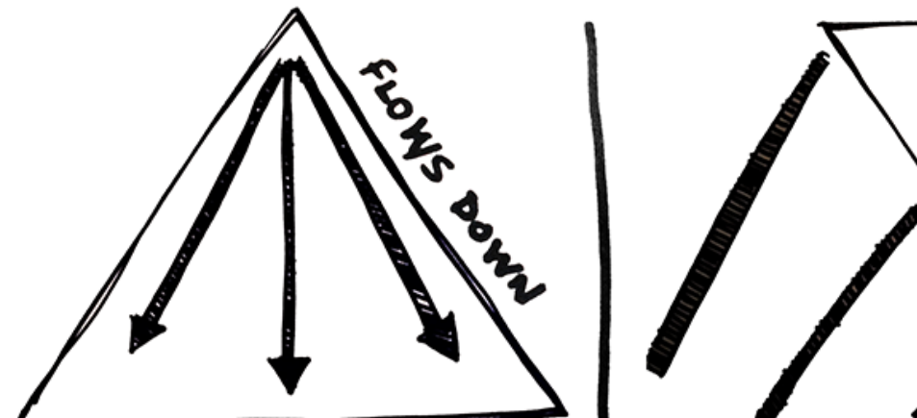
In this way of viewing power, the oil executive or head of state is inherently unstable. Like an upside-down triangle, unjust power and authority is unstable and will fall. To prevent that, that rely on supports to keep them upright—we call them pillars of support.
For example, oil executives are dependent not only on their managers, but other pillars of support like the company’s stockholders, the secretary who keeps track of their schedule, the tech workers who keep their cell phone and email functioning, their limo driver, truck drivers and ship captains who transport their oil, engineers and contractors who make the roads that the oil companies’ trucks move on, customers who buy their product, and so on.

The spectrum of allies
In most social-change situations there is a struggle between those who want the change and those who don’t. On the one hand, there are people who are active supporters of the change—not just people who believe in the change but people who are taking actions to make it a reality. On the other hand, there are people who are active opposers, people who actively take actions to prevent the change.
In campaigning, we often are focussed on those two groups — yet most people are somewhere between. Societies (towns, provinces, etc.) include a range of groups that can be put on a spectrum from closest to the point of view of your group to farthest away. This spectrum of allies illustrates this point.
The goal of the spectrum of allies is to identify different people—or specific groups of people—in each category, then design actions and tactics to move them one wedge to the left.
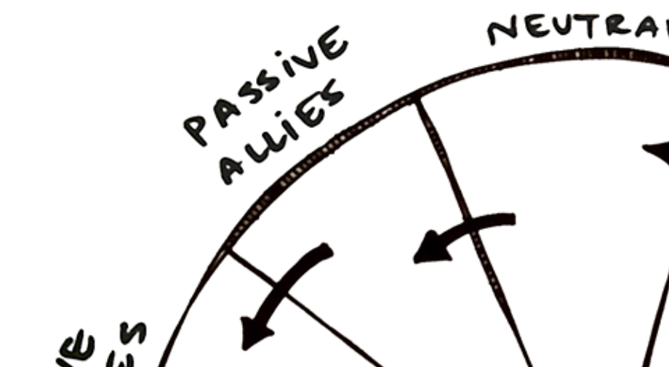
Good news: in most social-change campaigns it is not necessary to win over the opponent to your point of view. It is only necessary to move the central pie wedges one step in your direction.
This is important. If we shift each wedge one step, we are likely to win, even if the hardliners on the other side never move. That means our goal is not to convince the fossil fuel industry to end themselves. Instead, it is moving the rest of the society to shut them down.
Often activists have the mistaken idea that they need to win everyone to their side (which invites despair), or that we need to change the fossil fuel industry or other people actively fighting against the campaign (again inviting despair). When organisers bring an optimistic attitude, instead of one of despair, to the task of mobilisation, it is a lot easier to get people on board.
The Spectrum of Allies also reminds us there is a need for many roles. Different actions will reach folks at different places in the spectrum, so there are many ways to support a campaign, from lobbying politicians to marching in the streets.
This tool also evaluates our work. Can we show that we are measurably moving some segment of people over to our side? If not, we need to rethink our strategy.

Exercises

#1 - identify your target’s pillars of support

Use this to analyse the power of your campaign target.
Alone, in pairs, or depending on your group’s size in small groups, start by putting your target name in the center of the triangle.
Brainstorm different pillars of support. Who gives support to that target? Even if they disagree with them (or don’t care about their position), who are the people who carry out the orders or otherwise hold up that pillar? Be specific with the names of unions, media conglomerates, secretaries, and so on.
Gather back as a group, and let everyone present their diagram, and draw your group’s diagram based on everyone’s input.
If necessary, you may want to take some of those and make them into separate upside-down triangles with their own pillars of support.
Note: if your ultimate target is more seen an ally than as opposition, the pillars of support can also be viewed as the barriers that are holding your target back from taking action.

#2 - Draw your Spectrum of allies
Take some time to fill out the chart with specific people and groups. Think of specific individuals, both politically influential, but also socially influential, like elders and community leaders. (Read more about power-mapping.)
Share reflections and lessons in the whole group. Your group may realise it needs to do more research. Or it may have important, interesting debates about where people are on the spectrum.

Other lessons include:
- It is a huge win if you can get a group that was slightly hostile to move into neutrality.
- It is a huge win if you can get the group/wedge next to your end of the spectrum to move into activism.
- It is usually not necessary to move the opponents a step toward you in order to win, although it can make the win happen faster.
- This tool can identify areas of research by showing where you need to know more.
- It can show the importance of mapping out a range of people: those who are directly impacted by the situation, people who think of themselves as your allies, and people who are “powerholders” (government officials, etc). All of those people may be spread out across the spectrum so it is important to notice their range and how some of them may help you focus your efforts and support different aspects of your organising.
Notice which slices your group knows a lot, or a little, about. This shows which groups you should try to meet with in order to know more about that wedge of the spectrum of allies. Create a plan to reach out to them.

Questions to ask during the exercices
Try to be as specific as possible - whenever you mention a group, define it clearly. Try to name them as specifically as you can: “the inhabitants of this neighborhood” rather than “the public”; “the journalists of this local newspaper” or “national radios” rather than “the media”; “this union” rather than “workers”; “representatives from this party” or “city councillors” rather than “politicians”; etc.

Links to more resources
- Learn more about how these pieces all fit together in: What is a campaign?
- Read more about the Spectrum of Allies or Pillars of Support (or even more articles on spectrum of allies and pillars of support from our colleague organisation Beautiful Rising)
- Hear a story to show How Campaigns are Really Created
- Case Study: 350 Australia’s case of Winning by Thinking like their opponent (English-only)

