Group Formation Training Menu
a menu to start and facilitate
your campaign group

Introduction
Starting a campaign group, and keeping it running, isn't an easy thing to do. It comes with many leadership challenges: it takes time, it takes energy, and very different kinds of skills. It's easy to get lost or to feel overwhelmed. But it also comes with a lot of fun, a lot of learning, and, often a lot of impact - sometimes much more than you would expect. There’s nothing as empowering as seeing a campaign you’ve contributed to, start achieve results greater than you could have dreamed.
But yes, there are moment of doubts, of feeling at a loss, uncertain. Many of us have been there - and will be there again. This is where this document comes from. It is an attempt to make your life easier as you form - or reform - your campaign group. It works as a "menu" - from which you can pick a few ideas, or that you can chose to follow from the starter to the dessert!
It includes tips and examples, as well as suggested exercises for what we have found are helpful steps for a group to go through in its first days, weeks and months.
There is, however, a key dimension of a group's life, that isn't reflected in this menu: the group as a living body, the group as a safe space, as a space that people like, care for and enjoy. You will start seeing success in your campaign once your group becomes such a space. In this menu, we offer some ‘dishes’ you might choose to share with your team. But it’s not only the food itself that is important - it’s how you come together to share it. Whenever you plan a meeting, a session, a training or an exercice, take this into account: your group's meetings should be joyful and pleasant moments. Whether they are hosted in someone's warm and comfy home; in a cold and empty squat; outdoors on a sunny spring afternoon; or late at night on the eve on an important action: take the time to enjoy being together, to welcome everyone as they are, as they feel, with their desires, their doubts, their fears, their background and their dreams. Eat the ‘dishes’ on this menu with joy!
At 350.org, we're convinced that a group can only work well long term if it is well facilitated. Whenever you organize a meeting, try to stick to the announced start and end times, to show respect for the time and energy that people have committed. If the group hasn’t achieved your goals in the desired time, ask your team for advice about what to do next, and what would meet their needs.
Meetings that feel chaotic, or with endless discussions, will frustrate participants and make them less likely to stay engaged. Aim for a peaceful, purposeful, love-filled environment, with efficient decision-making, to keep people engaged.

The menu
The menu includes 7 different “meals.” It should help your group transition from an idea (I want to start a Fossil Free group) to a campaign - i.e. a group organized around a strategy, with a clear target, and organised to achieve its goals.
Each ‘meal’ on the menu is organised in a similar way: it begins with a summary of the session’s goals; includes a suggested time table for a group workshop; then an overview of the key notions; one or two exercises; and links to go further.
We suggest that it’s most helpful to go through them beginning with the first one, ending with the last one. But depending on your (and your group’s) experience, you might want to change the order - or to replace a meal with another that you’ve cooked yourself! You might also want to pick ideas from this menu, but build your own course. Be flexible - it is important to respect your group’s identity, pace and appetite.
Or, you can follow this menu step by step, as a frame and guide for your group’s first meetings. Just remember that beside the suggested time table, it is important to take more relaxed time at the beginning and at the end of each formal session. This will enable you to welcome everyone (especially new members), as well as to have informal discussions. You’ll be able to talk about your group’s work & celebrate what you have already achieved.
So, for example, when we suggest a 90 minute agenda, this should ideally be within a 120-150 minutes long meeting.
For groups who want to really go deep fast, you could consider a full day or weekend retreat as a group.
Please remember that you can reach out for support at any stage - either to your local / national contacts, or to 350’s Fossil Free campaign staff. If you don’t know who to contact, see gofossilfree.org/contact or email community@gofossilfree.org
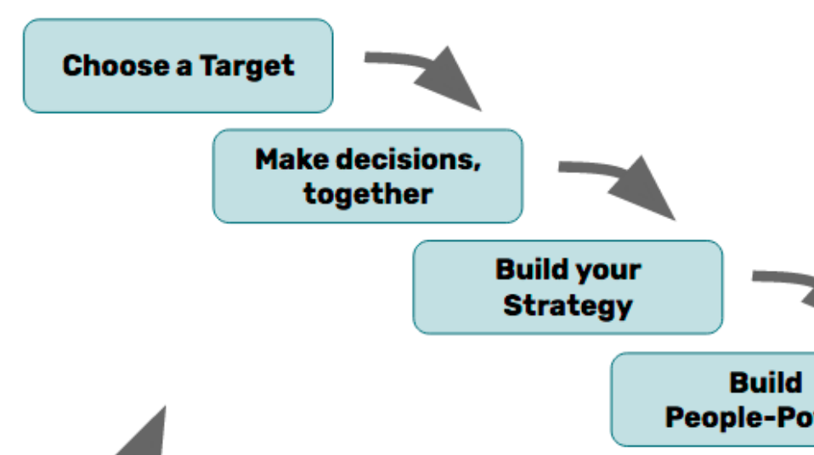

‘Starter courses’

Workshop 1 - Choose a target
This is where a campaign begins: with a target!
It might be too early for your group to make a decision, but you will narrow down your options, to help your group arrive at a strategic focus.
Link to workshop

Workshop 2 - Make decisions together
In your campaign journey together, your team will have to make hundreds of decisions, big and small. People in your group might have different ideas about what roads to take. And sometimes you can’t get all the information you want, before you need to choose a path. This workshop explores how to make good decisions, together.
Link to workshop

Main dishes

Workshop 3 - Build your strategy
Now that you’ve chosen your target, it’s time to identify your strategy - a path that gets you from where you are now, to a future where you have won change. This workshop will help you identify the barriers to change, and plan how to remove them, one after another, until you win!
Link to workshop

Workshop 4 - Build People Power with digital tools
Social movements are powered by people. This workshop explores how groups build people-power, and what digital tools might support that work.
Link to workshop

Workshop 5 - Share your Story
Each of us has a compelling story to tell. As you learn this skill, you will be learning to tell a story about yourself and the community you organize with. You will work to find a strong story that motivates others to join you in creating change, and you will gain practice in listening, and coaching others to tell a good story.

Link to workshop

Workshop 6 - Create your campaign timeline
Campaigns live on events and actions. Those actions bring more people in, build relationships, teach about the issue, and ultimately put pressure on people to make change. This session helps a group think about the kinds of actions it will take!
Link to workshop

Dessert! Sweets!

Building an effective team
This workshop is a bonus ‘palate cleanser’ - you don’t have to wait until the end to enjoy this workshop - insert it into your workshop series, whenever your leadership team feels it is needed for your group.
To change the world, we need to work together. Teamwork is at the heart of every successful campaign. Do you want to be part of a team that is effective, powerful, enjoyable, and filled with supportive relationships? This session will help your group think about how to become a team like that!
Link to workshop

