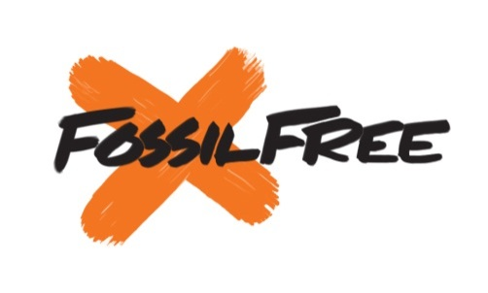**We call on [Your Campus Here]

**

*OUR DEMAND:*

1. *Freeze new fossil fuel investments immediately.*
2. *Full fossil fuel divestment within five years*

We believe such action on behalf of the University of New Mexico will not only be a sound decision for our institution’s financial portfolio, but also for the wellbeing of its current and future graduating classes, who deserve the opportunity to graduate with a future not defined by climate chaos.

**Signed:**  Name __________________________________ Email______________________________________

City_______________________________, ZIP_________________________, Phone_________________________________________________________

**I am a (circle one): Student Faculty/Staff Alumna/Alumnus Other**

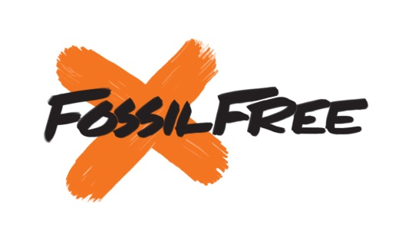**www.Act.GoFossilFree.org/Sign/Fossil_Free_UNM**

**We call on [Your Campus Here]

**

*OUR DEMAND:*

1. *Freeze new fossil fuel investments immediately.*
2. *Full fossil fuel divestment within five years*

We believe such action on behalf of the University of New Mexico will not only be a sound decision for our institution’s financial portfolio, but also for the wellbeing of its current and future graduating classes, who deserve the opportunity to graduate with a future not defined by climate chaos.

**Signed:**  Name __________________________________ Email______________________________________

City_______________________________, ZIP_________________________, Phone_________________________________________________________

**I am a (circle one): Student Faculty/Staff Alumna/Alumnus Other**

**www.Act.GoFossilFree.org/Sign/Fossil_Free_UNM**

We call on [Your Campus Here]

*OUR DEMAND:*

1. *Freeze new fossil fuel investments immediately.*
2. *Full fossil fuel divestment within five years*

We believe such action on behalf of the University of New Mexico will not only be a sound decision for our institution’s financial portfolio, but also for the wellbeing of its current and future graduating classes, who deserve the opportunity to graduate with a future not defined by climate chaos.

**Signed:**  Name __________________________________ Email______________________________________

City_______________________________, ZIP_________________________, Phone_________________________________________________________

**I am a (circle one): Student Faculty/Staff Alumna/Alumnus Other**

**www.Act.GoFossilFree.org/Sign/Fossil_Free_UNM**

**We call on [Your Campus Here]

*OUR DEMAND:*

1. *Freeze new fossil fuel investments immediately.*
2. *Full fossil fuel divestment within five years*

We believe such action on behalf of the University of New Mexico will not only be a sound decision for our institution’s financial portfolio, but also for the wellbeing of its current and future graduating classes, who deserve the opportunity to graduate with a future not defined by climate chaos.

**Signed:**  Name __________________________________ Email______________________________________

City_______________________________, ZIP_________________________, Phone_________________________________________________________

**I am a (circle one): Student Faculty/Staff Alumna/Alumnus Other**

**www.Act.GoFossilFree.org/Sign/Fossil_Free_UNM**

_____, GO FOSSIL FREE!

Dear University President ________________;

Climate change is accelerating. In this last year alone our country experienced record-breaking heat, droughts, and hurricanes. The scientific consensus is clear and overwhelming; we cannot safely burn even half of global fossil-fuel reserves without dangerously warming the planet



www.350.org www.facebook.com/350NM

_____, GO FOSSIL FREE!

Dear University President ________________;

Climate change is accelerating. In this last year alone our country experienced record-breaking heat, droughts, and hurricanes. The scientific consensus is clear and overwhelming; we cannot safely burn even half of global fossil-fuel reserves without dangerously warming the planet



www.350.org www.facebook.com/350NM

_____, GO FOSSIL FREE!

Dear University President ________________;

Climate change is accelerating. In this last year alone our country experienced record-breaking heat, droughts, and hurricanes. The scientific consensus is clear and overwhelming; we cannot safely burn even half of global fossil-fuel reserves without dangerously warming the planet



www.350.org www.facebook.com/350NM

_____, GO FOSSIL FREE!

Dear University President __________________;

Climate change is accelerating. In this last year alone our country experienced record-breaking heat, droughts, and hurricanes. The scientific consensus is clear and overwhelming; we cannot safely burn even half of global fossil-fuel reserves without dangerously warming the planet



www.350.org www.facebook.com/350NM